

Metrc Connect – How to Generate Keys in Connect
Here is the process to generate your Production and/or Sandbox keys with Metrc Connect.
- You will log in to Metrc Connect using your UserName and Password and go to the KEYS section on the left side. See below.
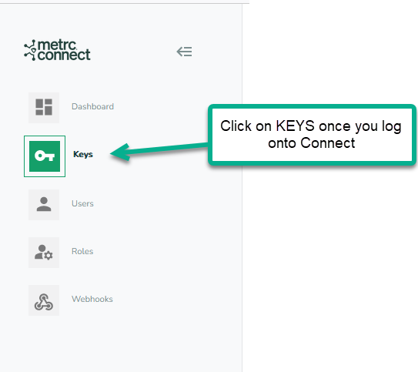
- Then you will choose Generate Key
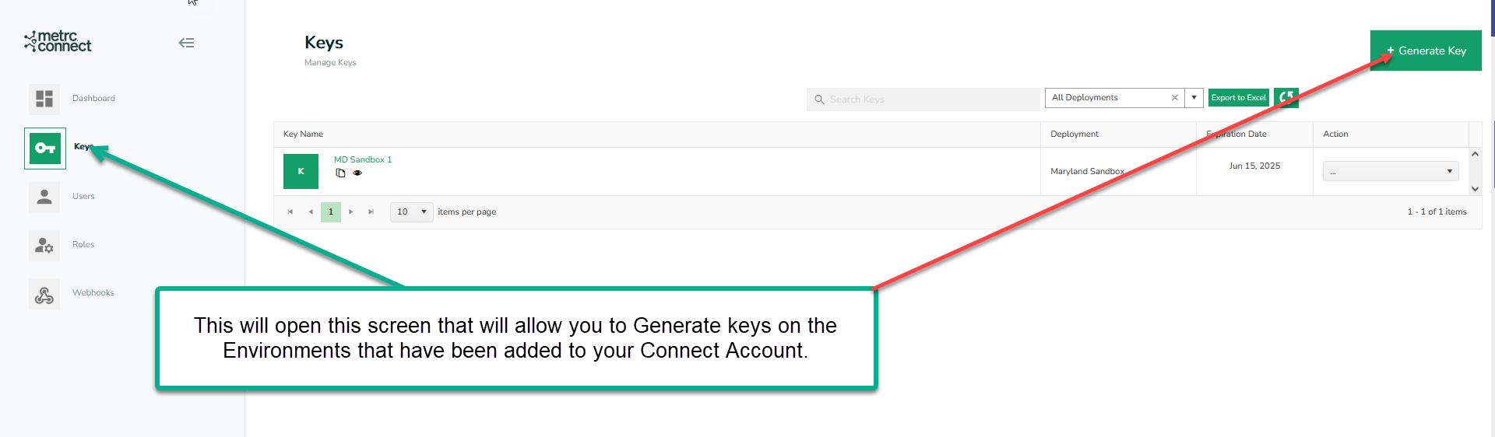

- This screen will open, and you can Name your key, choose the State Deployment for Production or Sandbox Environment.

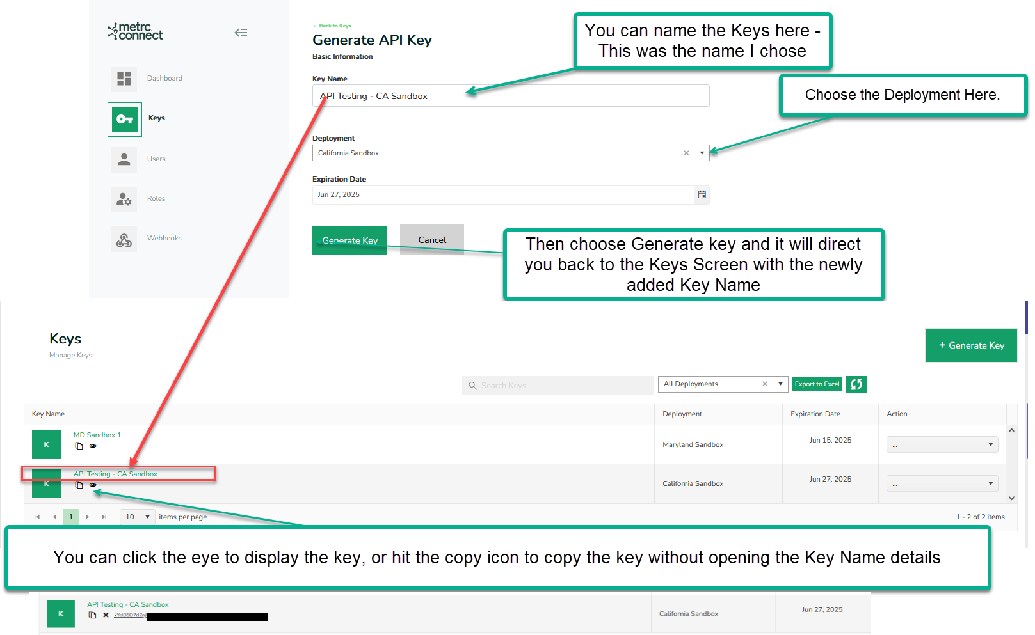
- When you Generate the key, it will resume to the previous page with the keys you have under the Keys Tab (see above bottom portion of screenshot). You can click on the name to open the details or for a quick look you can use the eye icon to see or the copy icon to copy it.

